|  |  |
| --- | --- |
|  | |
| **Web Engineering** | |
| **Submitted to :**  **Dr. Nida Imran** | |
| Assignment 1 | Portfolio Site |
| Submission Date: | Oct 18, 2024 |

|  |  |
| --- | --- |
| **S. No** | **Name** |
| Name | Ibrahim Aslam [BESE-28(C)] |

Hero Section of the site

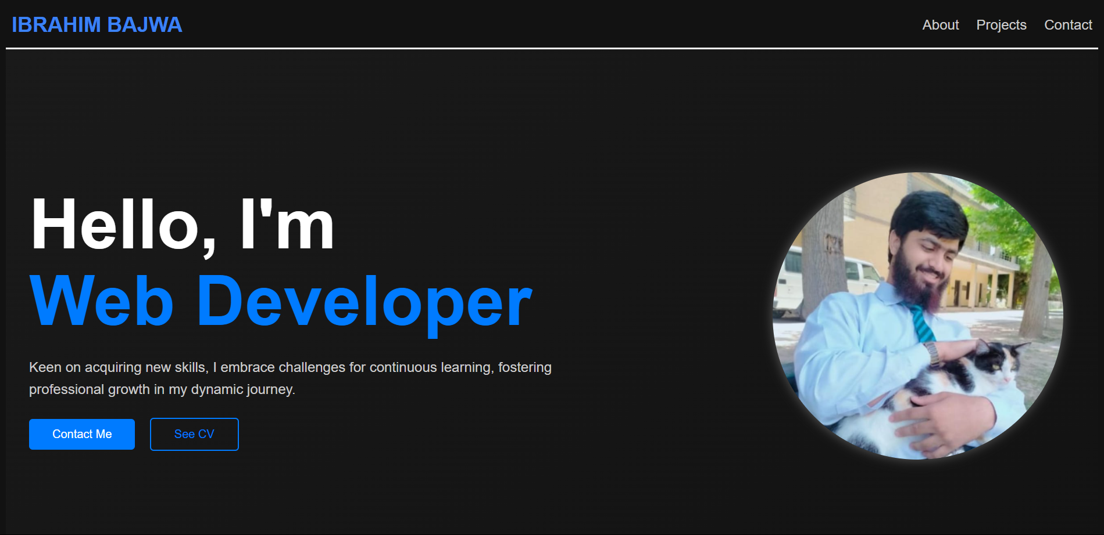

About page of the website

.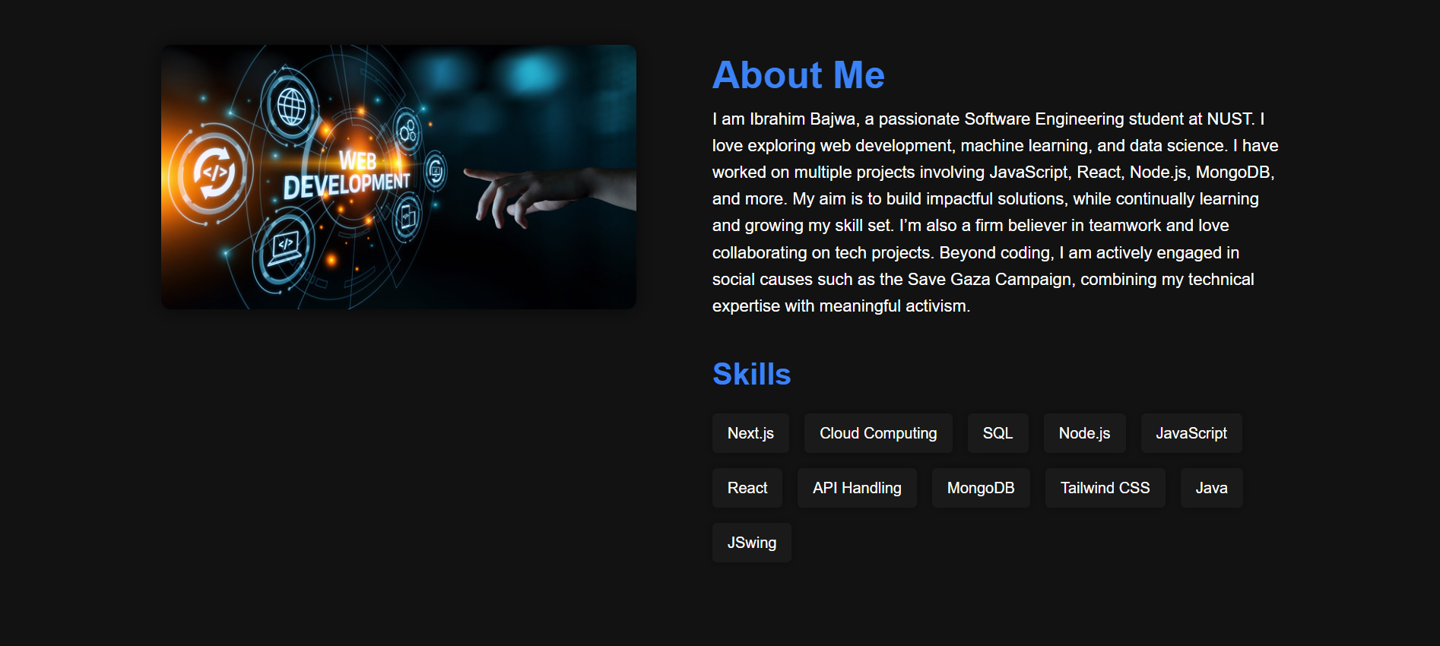

Projects on the website

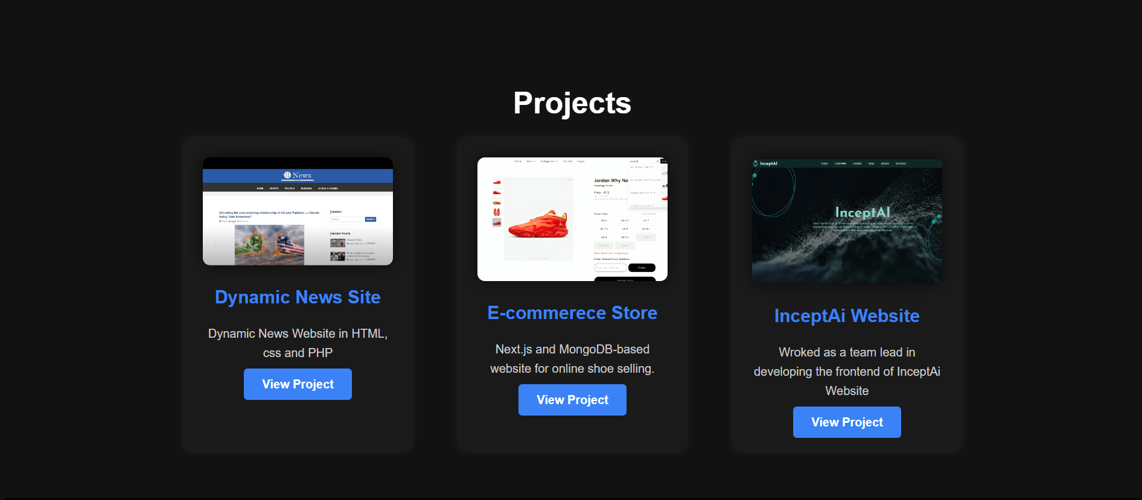

Contact page on the website

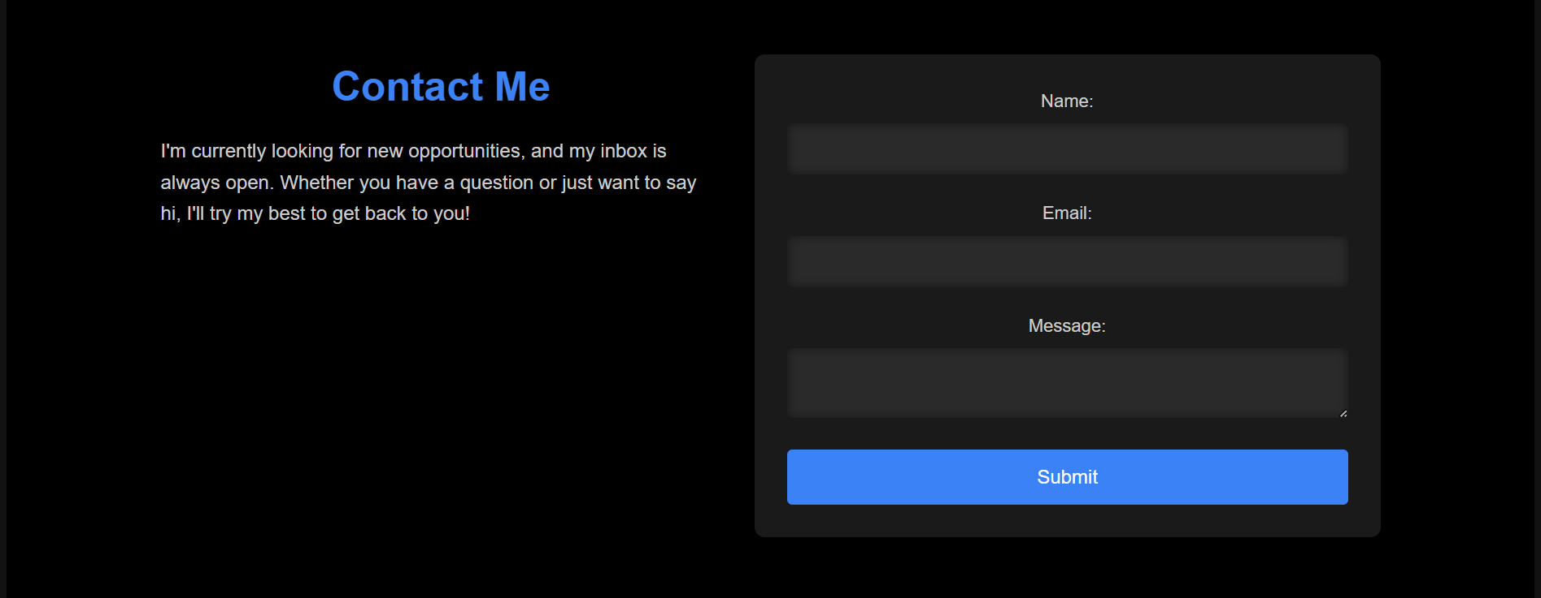

View on the Smaller Screens

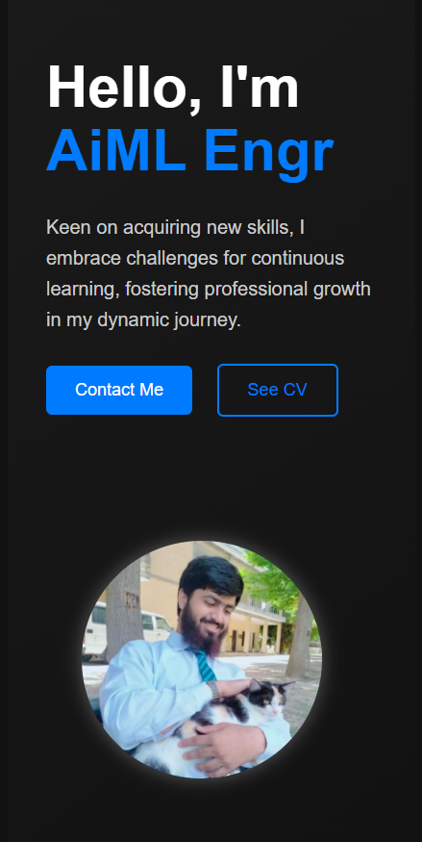 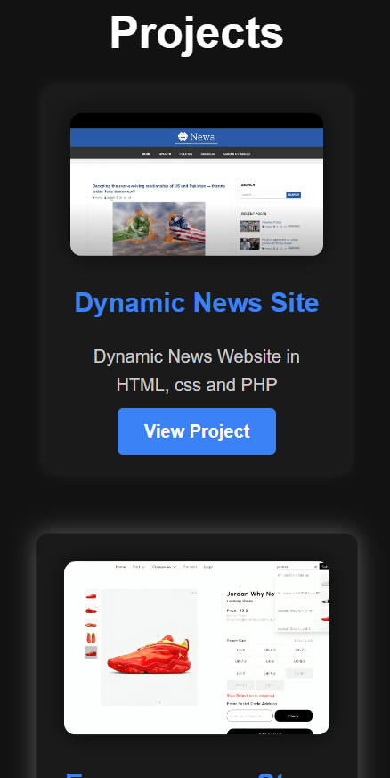 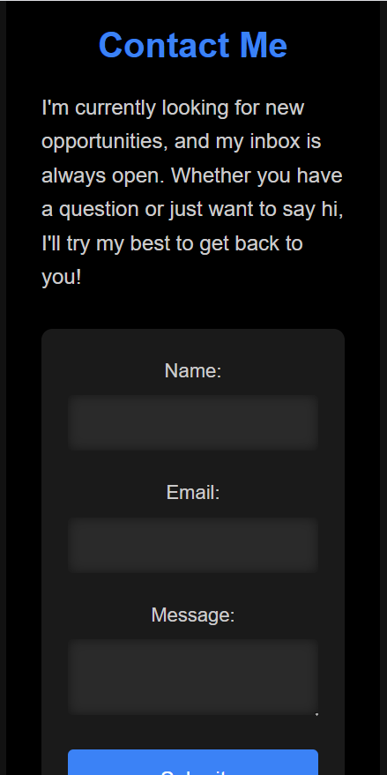

DOCUMENTATION:

I primarily work as a Next.js developer, using React and Tailwind CSS for styling. However, today while working with simple HTML and CSS, it felt a bit boring to switch between files for styling. Despite that, I enjoyed it a lot as it helped me revise many of my CSS concepts. It also became quite interesting when I tried to clone my professional portfolio, which was originally built in Next.js.